Linear Regression Task 6   
Hansel Aditia Hartono – 2602067874  
Ignatius Kennard - 260206719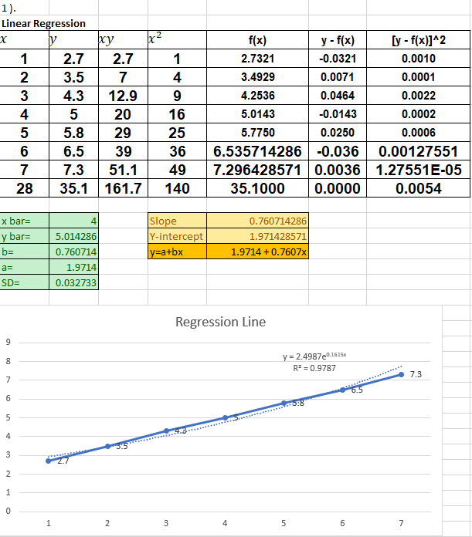3

